Casual Jobs Database v.1
Client Acceptance & Feedback Form


Wireframe
To:
Clement Sudhakar Swarnappa
Senior Academic Staff Member
School of Information Technology
DDI: +64 4 830 3130
Email: clement.sudhakar@weltec.ac.nz
URL: www.weltec.ac.nz
Post : Private Bag 39803, Lower Hutt 5045
Wellington, New Zealand

Project Team:
Supun Chandra Malimage – Project Manager
Kalaivani Ilango – Team Member
Ruban Ravi Sebastian – Team Member
Table of Contents
Client Acceptance & Feedback Form 3
Task description: 3
Sitemap: 3
Client feedback on Sitemap: 3
Questionnaire: 4
Employer questionnaires: 4
Job Seeker questionnaires: 6
Client feedback on questionnaire: 7
Wireframe design: 8
Home 8
Employer: 9
Job seeker: 12
Admin Dashboard: 14
Overall Client feedback: 16
Action Plan on this Milestone: 16
Next steps: 16

Client Acceptance & Feedback Form

Milestone - Wireframe design approval
Project Name: Casual Jobs Database V.1 | Client Name: Clement Sudhakar Swarnappa
Project Start date: July 6th, 2020 | Project End date: October 9th, 2020
Milestone: Wireframe design approval | Finished date: August 28th, 2020
Introduction of Milestone:
- Site Map
- Questionnaire
- Wireframe design approval

Task description:
Based on the Rapid Application Development methodology, we have completed with analysing the requirements, gathered necessary information, and started with designing Sitemap, questionnaire, and Wireframe preparation.

Sitemap:
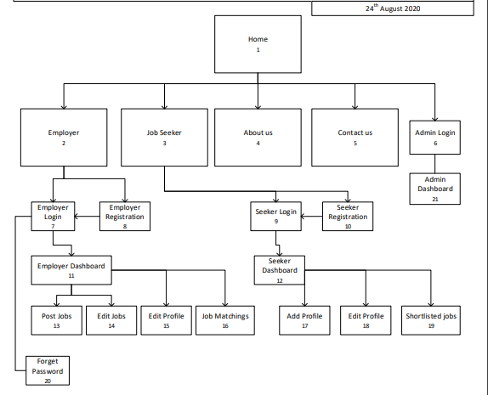

Client feedback on Sitemap:

Questionnaires:
Questionnaires has been prepared to match the requirements between Job seeker and Employer. This questionnaire would help to feed in both job seeker and employer details which supports the matching algorithm to select suitable candidate
Employer questionnaires: It is divided into 5 buckets, Job details, Job timing, Education, Experience, and other requirements.
Feedback: ………………………………………………………………………………………………………………………………………………………………………………………………………………………………………………………………………………………………………………………….
Feedback: ………………………………………………………………………………………………………………………………………………………………………………………………………………………………………………………………………………………………………………………….
Job Seeker questionnaires: It is divided into 5 buckets as Personal details, Availability, Education, Experience and other requirements.
Feedback: ………………………………………………………………………………………………………………………………………………………………………………………………………………………………………………………………………………………………………………………….

Client feedback on questionnaire:
Feedback: ………………………………………………………………………………………………………………………………………………………………………………………………………………………………………………………………………………………………………………………….

Wireframe design:

Home
This page shows the brief introduction of this web application and the functionalities involved in this application. It describes about employer, job seeker, job stats, about the application, testimonials, contact us etc.,
We can get information about jobs like, job title, location, category, and type. Also, we can get an insight about number of jobs posted, matching jobs, number of companies posted the jobs and number of job seekers registered into this application.
Client feedback:
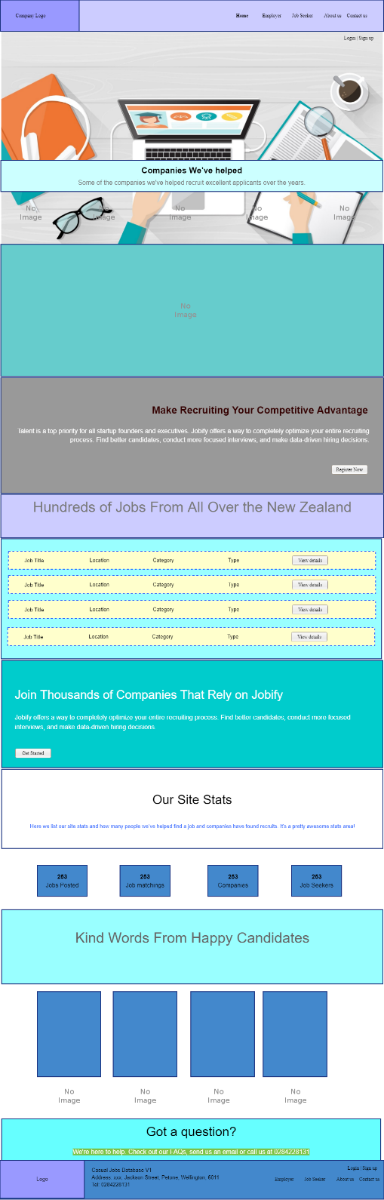
Feedback: ………………………………………………………………………………………………………………………………………………………………………………………………………………………………………………………………………………………………………………………….
Employer: If we click the employer tab, we will get the details of Employer login, Employer registration and Employer dashboard. Employer can directly login if they have already registered, else employer needs to register first to access the employer dashboard.
Client feedback:
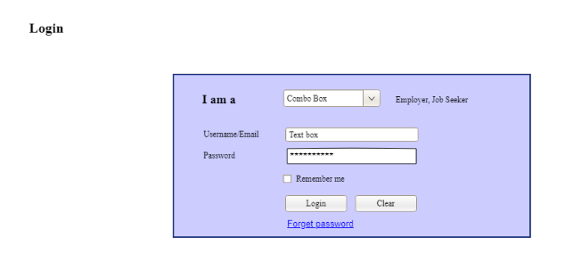
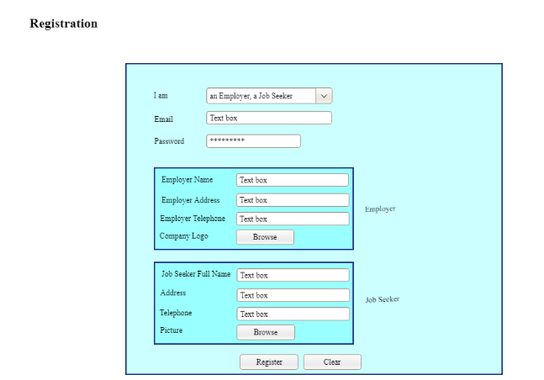
Feedback: ………………………………………………………………………………………………………………………………………………………………………………………………………………………………………………………………………………………………………………………….
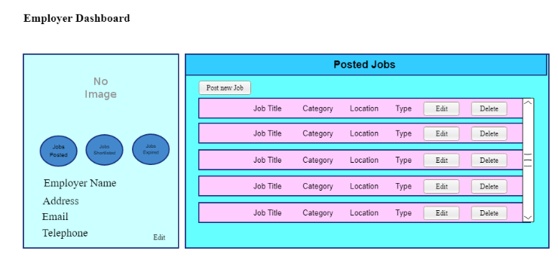
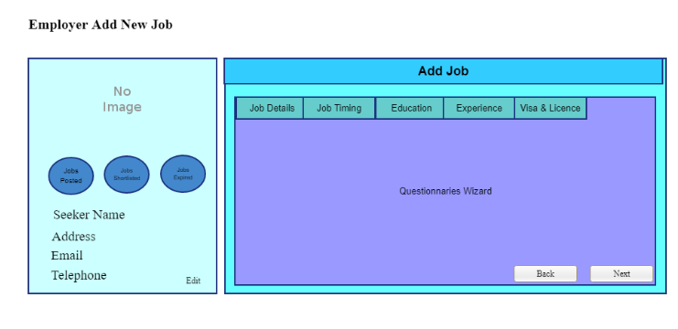
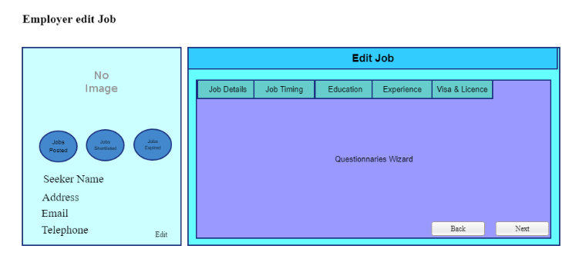
Feedback: ………………………………………………………………………………………………………………………………………………………………………………………………………………………………………………………………………………………………………………………….
Job matching: Under this page, employer could see the matching candidate profile based on the employer requirement.
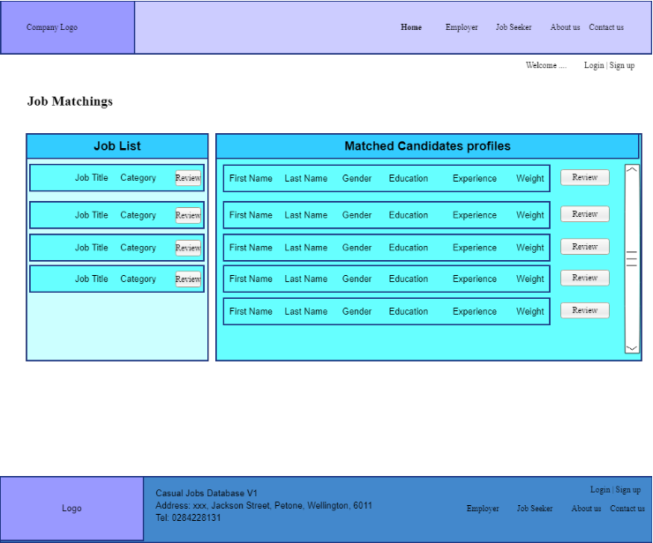
Feedback: ………………………………………………………………………………………………………………………………………………………………………………………………………………………………………………………………………………………………………………………….
Job seeker: If we click the Job seeker tab, it will take to the job seeker login page where the job seeker can login or register if they are a first-time user. Once registered, they can access the job seeker dashboard, number of jobs matching based on their education, experience and other requirements
Client feedback:
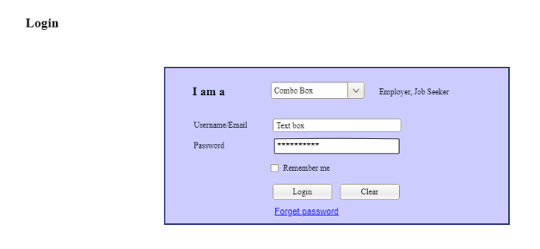
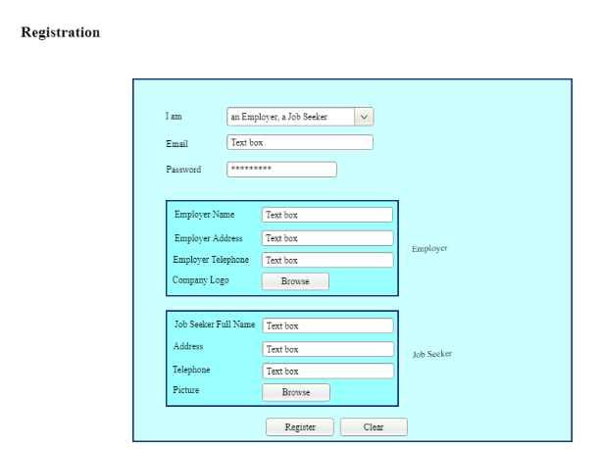
Feedback: ………………………………………………………………………………………………………………………………………………………………………………………………………………………………………………………………………………………………………………………….
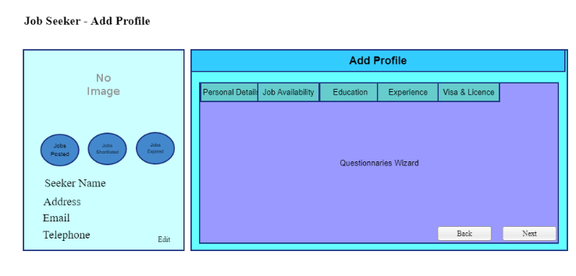
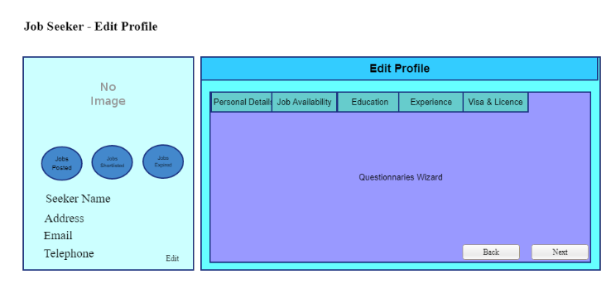
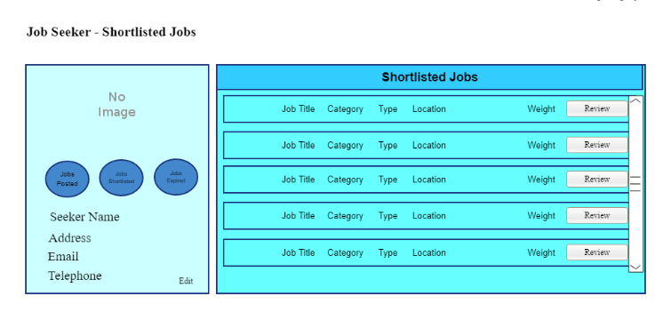
Feedback: ………………………………………………………………………………………………………………………………………………………………………………………………………………………………………………………………………………………………………………………….

Admin Dashboard:
The client who owns this application manages the admin dashboard and update details about job categories, education levels, tertiary institute, specialized areas etc.,
Client feedback:
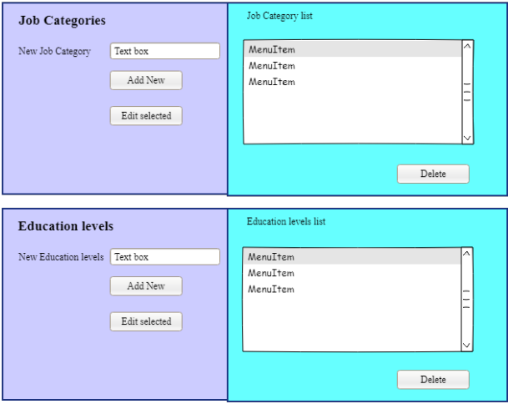
Feedback: ………………………………………………………………………………………………………………………………………………………………………………………………………………………………………………………………………………………………………………………….
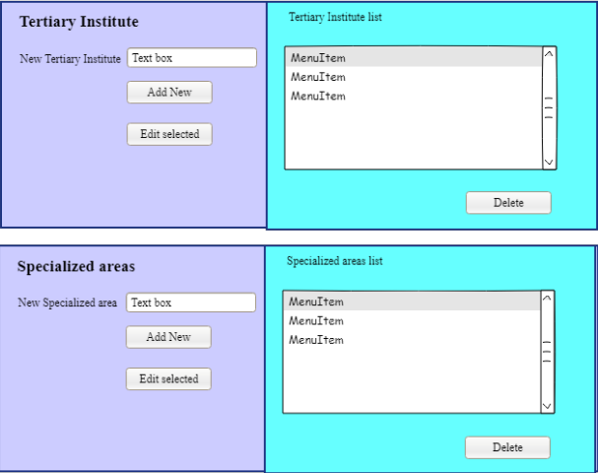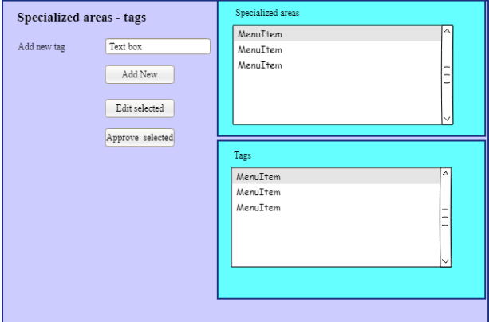
Feedback: ………………………………………………………………………………………………………………………………………………………………………………………………………………………………………………………………………………………………………………………….

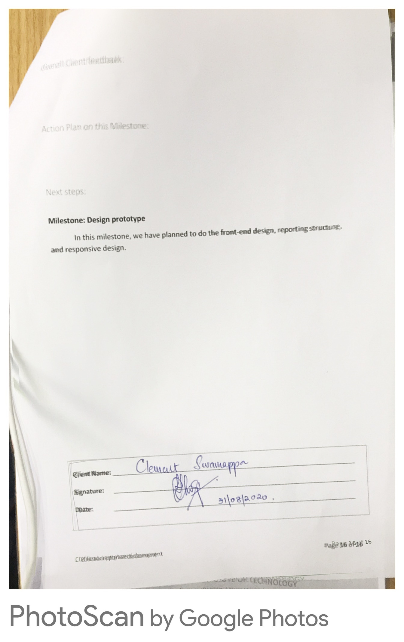
Overall Client feedback:

Action Plan on this Milestone:

Next steps:

Milestone: Design prototype
In this milestone, we have planned to do the front-end design, reporting structure, and responsive design.

Client Name: _____________________________________________________________________

Signature: _____________________________________________________________________

Date: _____________________________________________________________________

